**CSE225 DATA STRUCTURES PROJECT II REPORT**

**Entered Input:**

18 12 8 4 2 16 14 15 17 36 24 20 21 72 54

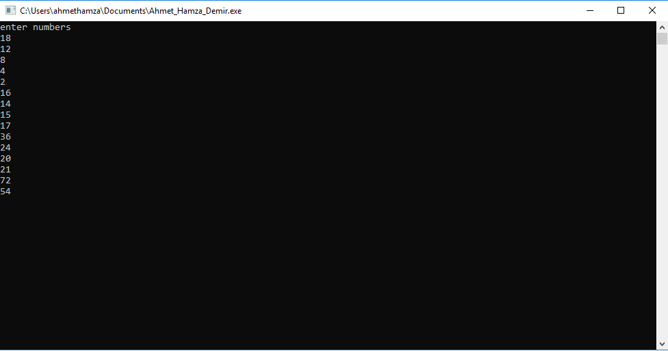

**Inordered Input:**

0 2 4 8 12 14 15 16 17 18 20 21 24 36 54 72

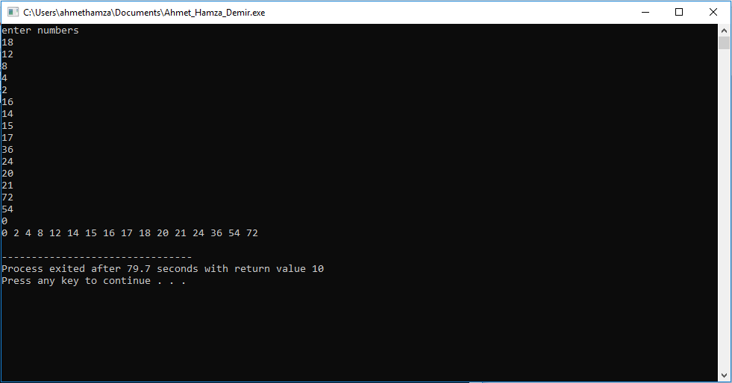

*Ahmet Hamza Demir 150116025*